Introduction to Agile
Agile is a modern software development methodology that focuses on flexibility, collaboration, continuous improvement, and customer satisfaction.
It was formally introduced in 2001 through the Agile Manifesto, created by 17 software developers to improve traditional development methods.

Why Agile?
Traditional models like the Waterfall model follow a fixed sequence (Requirement → Design → Development → Testing → Deployment).
If requirements change, it becomes difficult and costly.
Agile solves this problem by:
- Delivering work in small increments
- Allowing changes at any stage
- Encouraging continuous feedback
- Focusing on working software

Agile Manifesto – 4 Core Values
The Agile Manifesto emphasizes:
- Individuals and interactions over processes and tools
- Working software over comprehensive documentation
- Customer collaboration over contract negotiation
- Responding to change over following a plan

Key Principles of Agile
- Customer satisfaction through early and continuous delivery
- Welcome changing requirements
- Deliver working software frequently
- Close collaboration between developers and business teams
- Continuous improvement (Retrospectives)

Popular Agile Frameworks
- Scrum
  - Work is divided into short cycles called Sprints (2–4 weeks)
  - Roles: Product Owner, Scrum Master, Development Team
- Kanban
  - Visual board system
  - Focus on continuous delivery
- Extreme Programming (XP)
  - Emphasizes technical practices like TDD and Pair Programming

Agile Lifecycle
- Requirement Gathering
- Planning
- Design
- Development
- Testing
- Review
- Release
- Feedback & Improvement
(Repeated in short cycles)

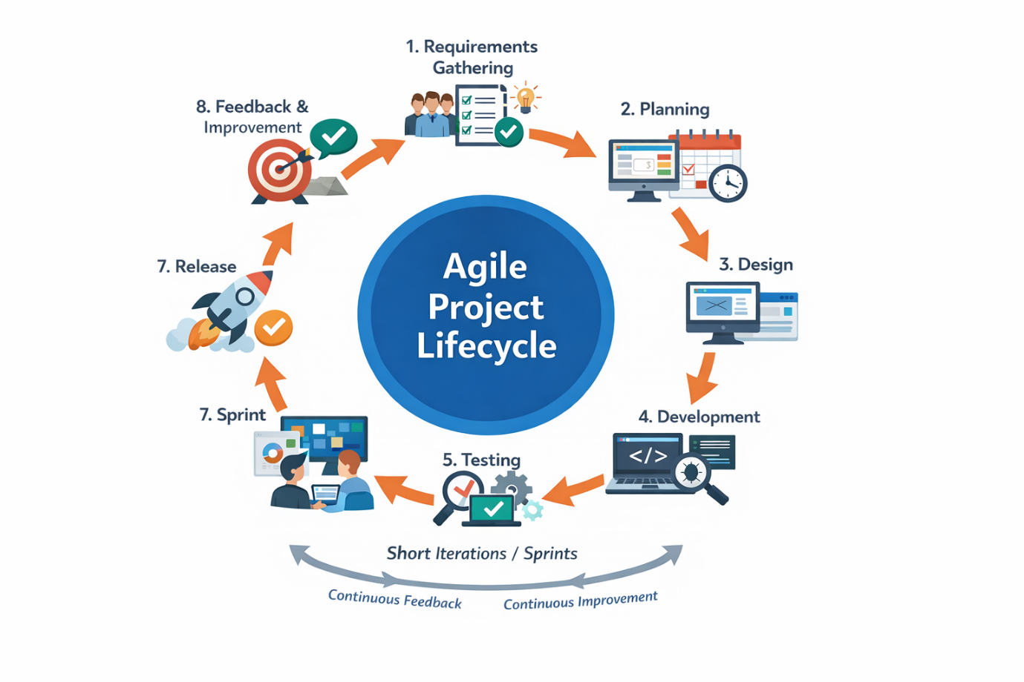

Advantages of Agile
✔ Faster delivery
✔ Better quality
✔ Higher customer satisfaction
✔ Improved team collaboration
✔ Reduced project risk

Simple Definition (Exam Point of View)
Agile is an iterative and incremental software development approach that focuses on collaboration, flexibility, and continuous delivery of working software.

Advantages of Agile
✔ Faster delivery
✔ Better quality
✔ Higher customer satisfaction
✔ Improved team collaboration
✔ Reduced project risk

